Week 4 Project

Aubrey D. Soule
IT, Software Development and Coding, ECPI University
SDC330: Advanced Programming Using Java
Dr. Helio Castro
May 3, 2026

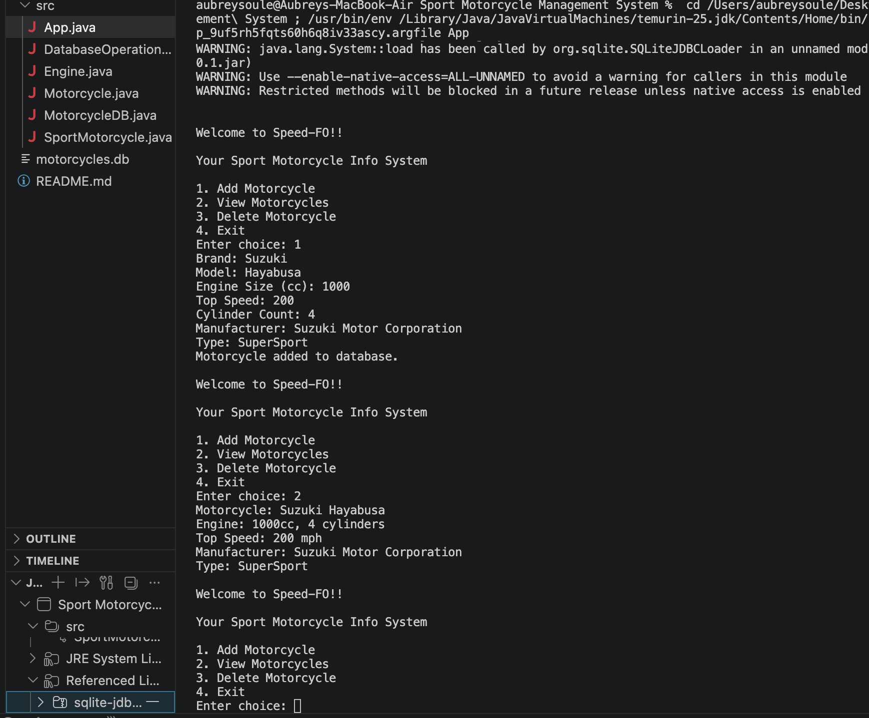
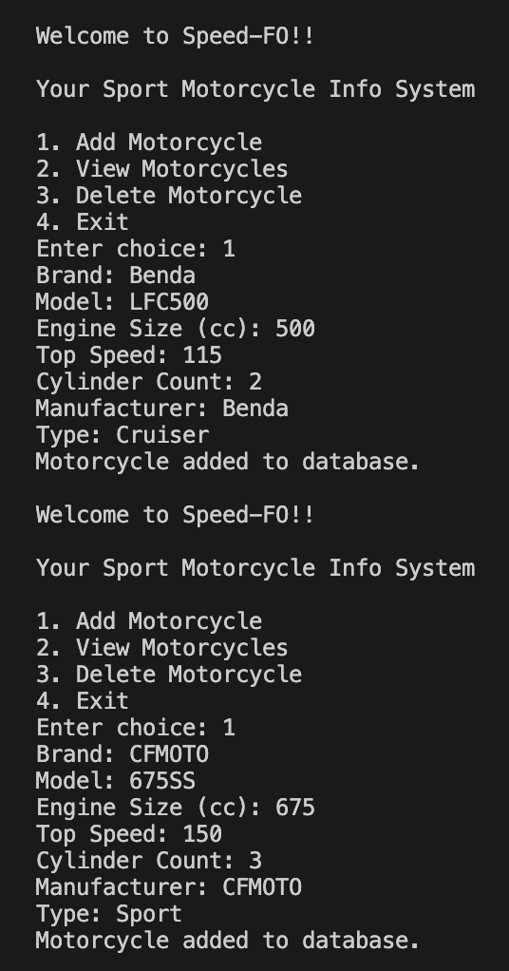
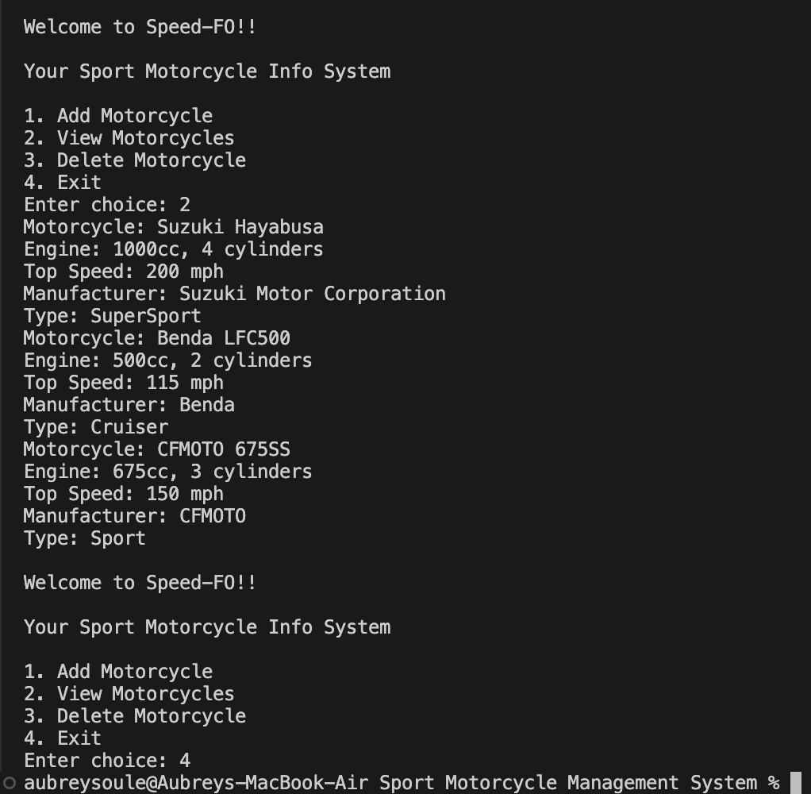

References

